PSA, Inc.

Wireless 9000

Desktop

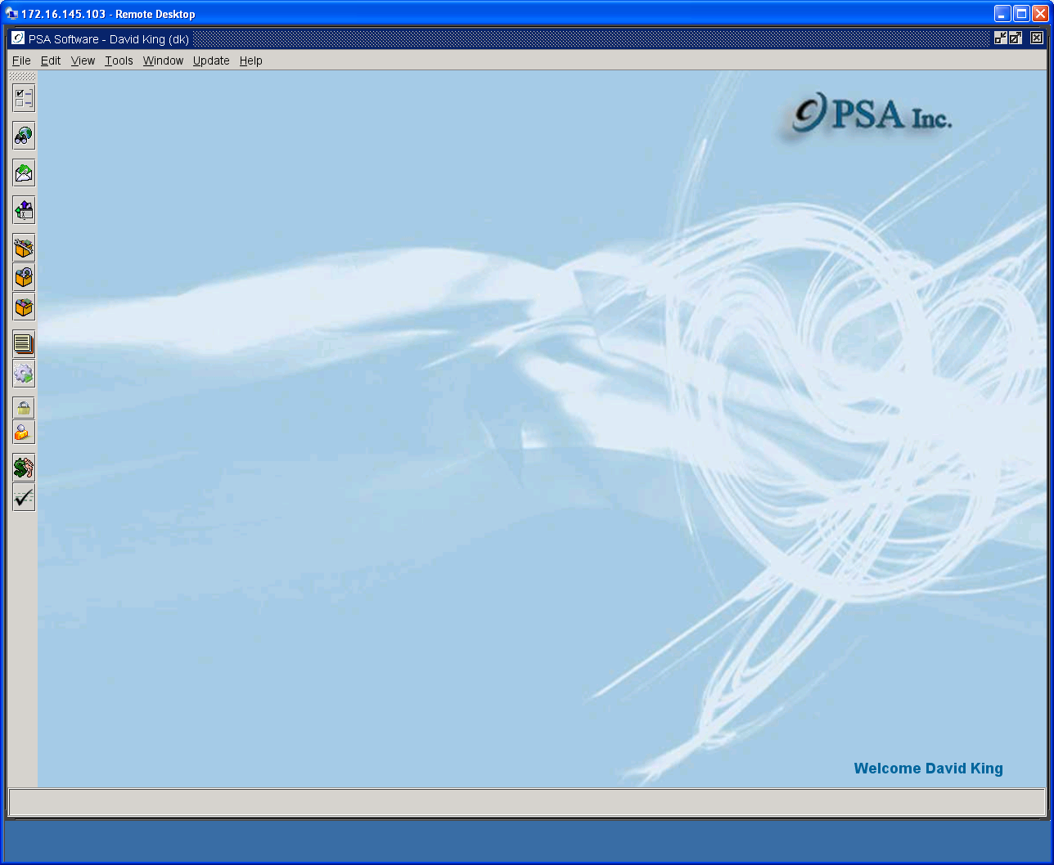

Batch Adjustments

& Payments

Table of Contents

Batch Adjustments 3
Create New Adjustment Batch 3
Trial Balance Adjustment Report 7
Deleting Un-Posted Adjustments 8
Post Adjustment Batch/Print Final Batch Report 9
Removing Posted Adjustments 10
Batch Payments 11
Create New Batch 11
Scanning Payments 12
Manual Entry of Payments 12
Trial Balance Payment Report 13
Deleting Un-Posted Payments 14
Posting of Payments 15
Removing Posted Payments 16
Retrieving Payment Reports – Payment Batch Report 17
Finding Payments 18
Payment Search Report 18
Locating Batches or Checking for Non- Posted Batches 19
Possible Payment Duplicates Report 20

Batch Adjustments
Click on the Batch Adjustments and Payments icon on the left toolbar. Expand Adjustment Batches in the Batches tree.

This option allows the user to create groups (batches) of transactions that affect the customer accounts receivable. The option has two steps. The first step is to create the batch. The second step is to post the batch of transactions to the customer’s account receivable. Each step has independent authority from the other. Many companies allow CSR’s to create the batches, but only a supervisor has the ability to post the batches. All batches, including system-generated batches, must be posted before the accounts receivable is affected. Highlight the heading Adjustment Batches in the tree and press the New icon to begin adjustment entry.

Create New Adjustment Batch

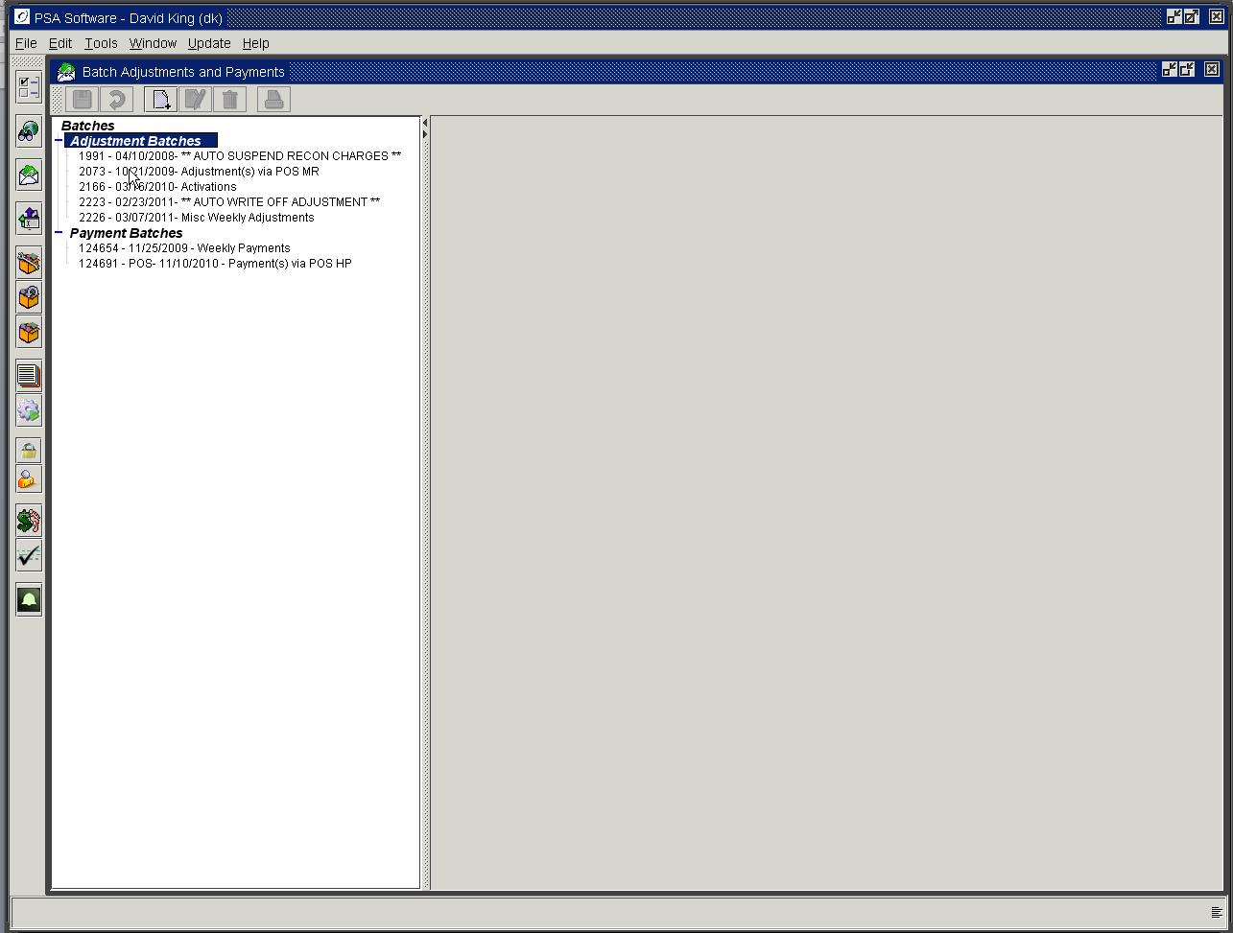
Create new batches.

Pressing the new icon opens the data entry screen.

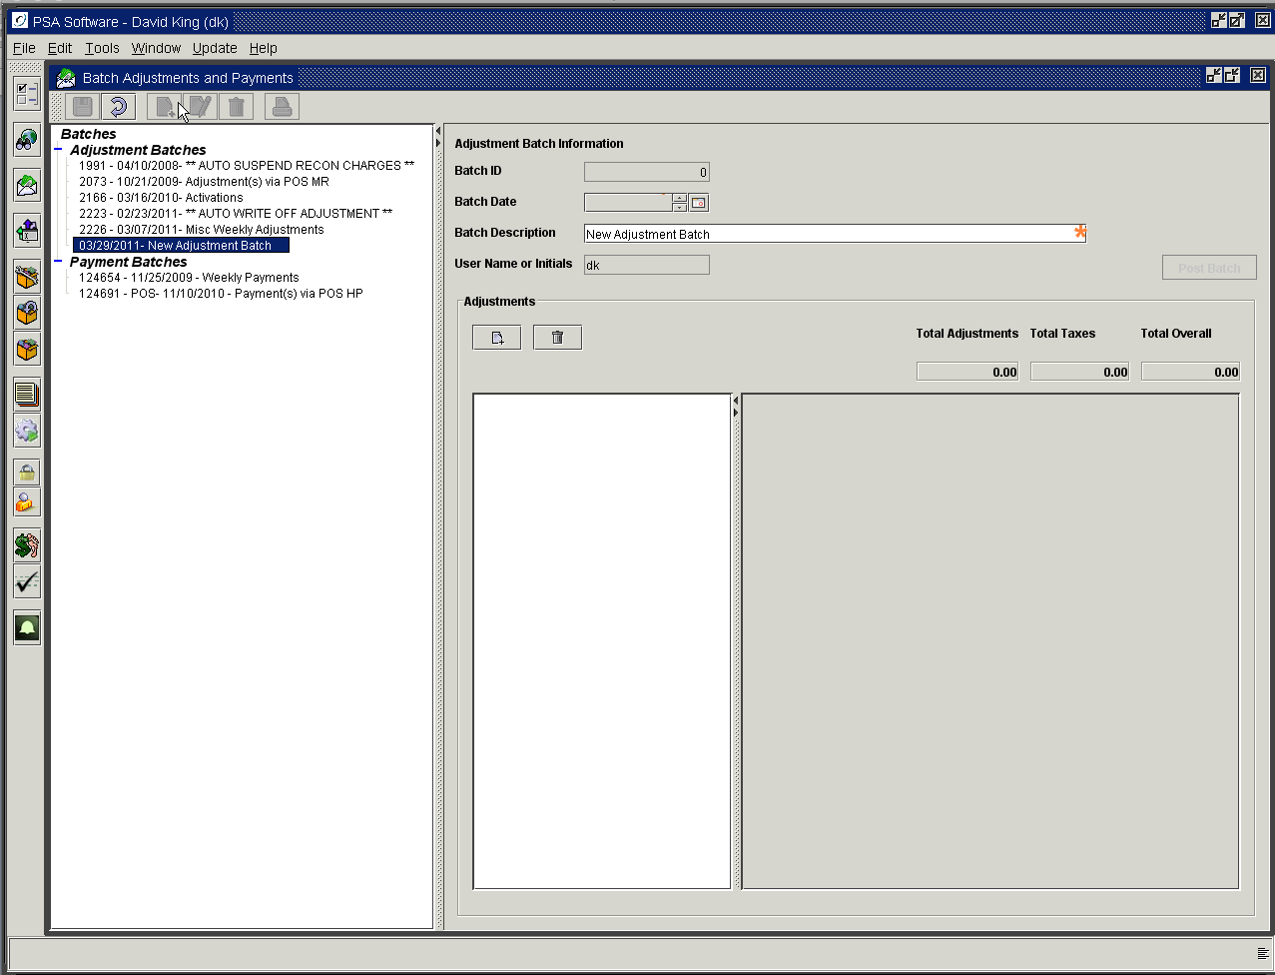
Delete individual adjustments
Create individual adjustments

Batch ID: This is a system generated identification number.
Batch Date: The default is the current day’s date. Batches can be dated in the past up to the beginning of the cycle or future dated. Backdating will post the adjustment immediately to the accounts receivable. Future dating will also post to the customer’s accounts receivable, however at billing time the adjustment will not be considered in the calculations and will be moved to the next cycle. This can be very confusing to customers/CSRs.
Batch Description: Enter a text description of the batch.
User Name or Initials: The user sign on name is defaulted, showing the batch generator.

Post Batch: This button is active when entries are created in the sub-list tree. This applies all the adjustments in the open batch to the various customer’s accounts receivable. All batches should be posted prior to billing to correctly adjust the customer’s statement balance.

Adjustment Sub frame

Select the New icon in the Adjustments sub frame.

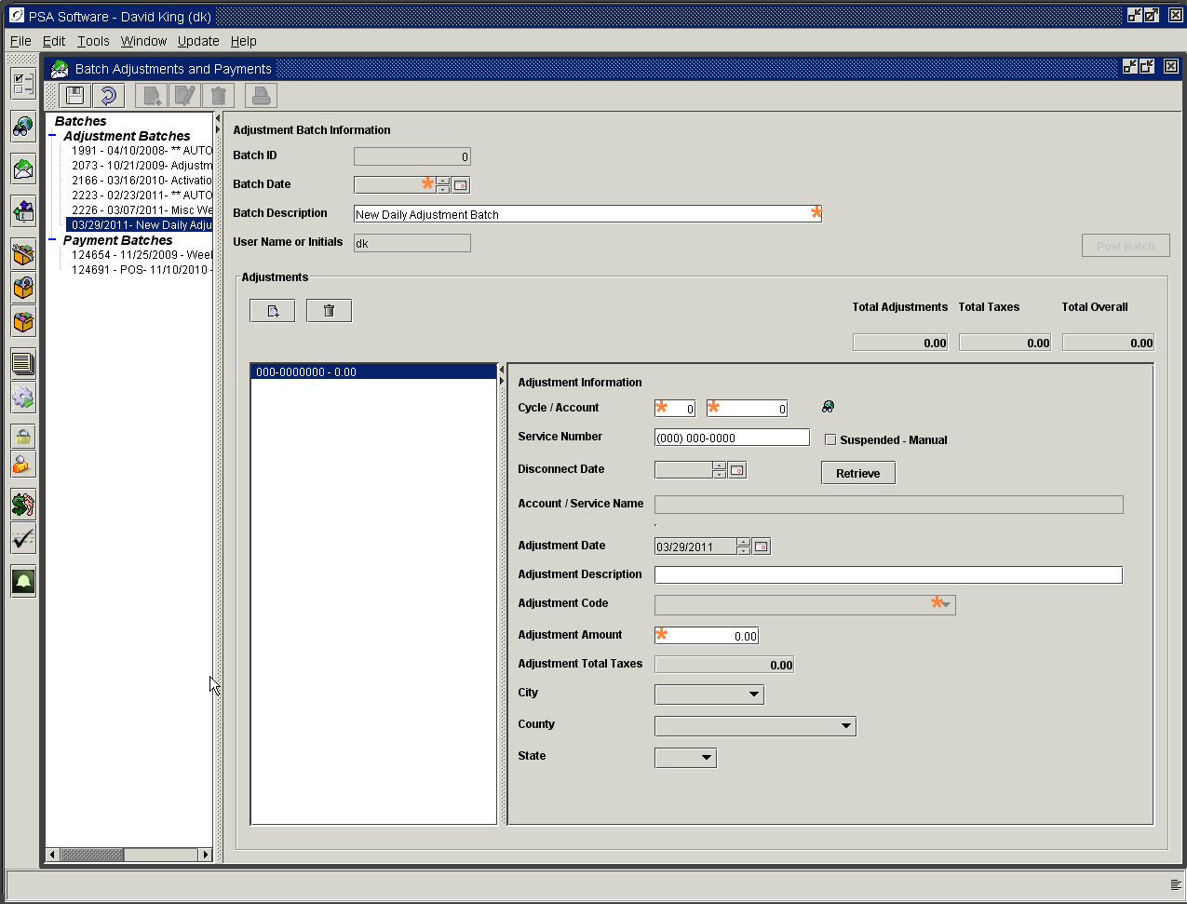

Cycle/Account: You may enter either the cycle/account number or the service number to select the account for the adjustment. If you are going to use a service level adjustment, you are required enter a service number for the adjustment to be valid. If not you will see a message requesting you enter a service number. Additionally, if the service number is a disconnected number then you must enter the disconnect date in the field immediately following the service number field.

Search: If you need to look up an account number or service number, press the Search icon next to account number. Enter the information you have to find the customer’s account and press the Search button; pressing Enter will close the search panel. Highlight the customer record and press the OK button to select the account/service.

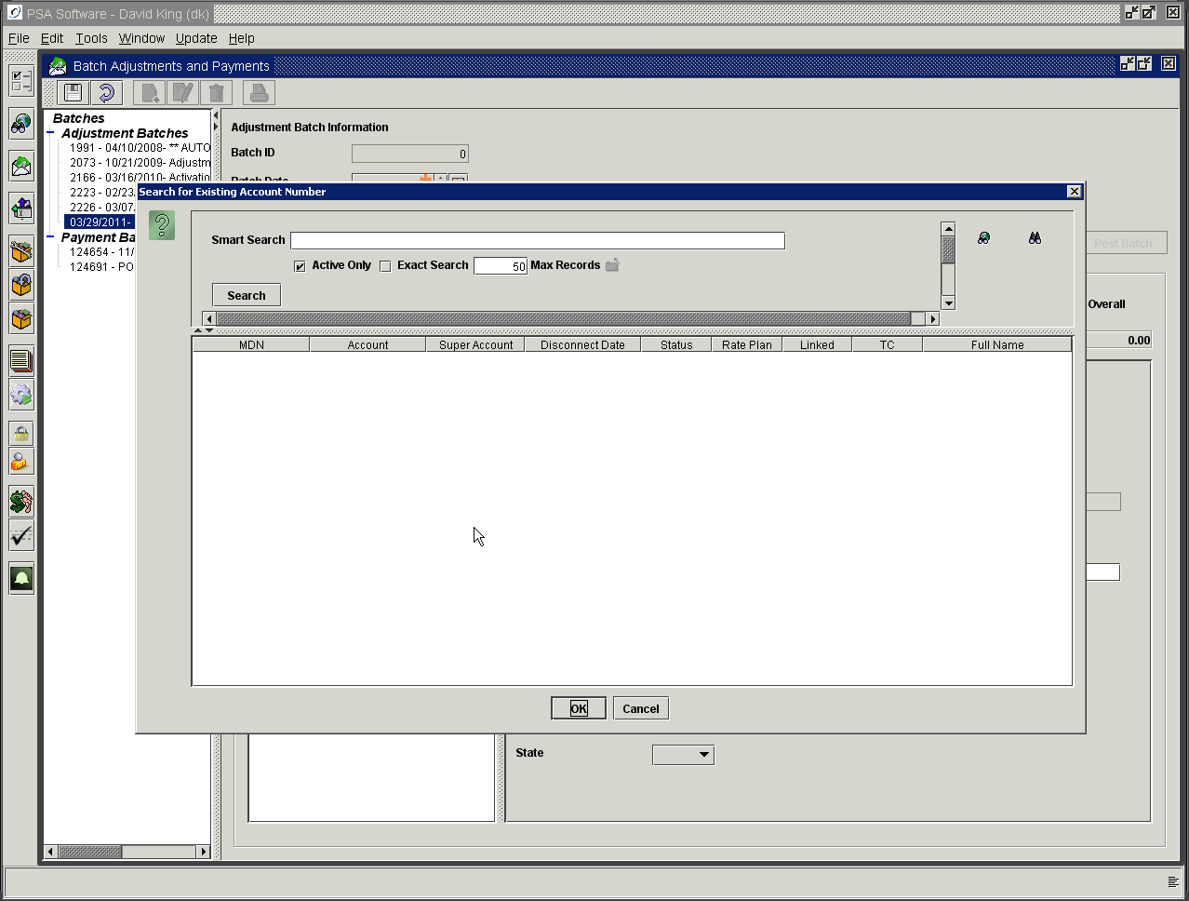

Service Number: Enter the service number if the adjustment type is specifically for the service level.
Suspended –Manual: If the service number has been Suspended Manually, place a check in the box to retrieve the customer information.
Disconnect Date: If the service number is disconnected, you must enter the Disconnect Date to correctly identify the service number you want to adjust.
Retrieve Button: After account or service number has been entered press the Retrieve button to verify the number and return field values.
Account/Service Name: No entry is required; this field will be defaulted from the account or service number.
Summary Accounts Receivable: Balances for the account will be shown in the accompanying table.
Adjustment Date: This will be the install date of the adjustment item on the customer’s account and will show on the statement. This date can be independent of the batch date but is defaulted to today’s date.
Adjustment Description: This should be used for an additional text description of the reason for the adjustment. This will be displayed along with the amount and adjustment code on the Transaction History Report.
Adjustment Code: This dropdown displays all the “A” type items setup in the database. The user will select the appropriate code from the dropdown by highlighting and single clicking the item.
Adjustment Amount: If the adjustment item is setup with a default value, that dollar value will be displayed. If there is no amount set up on the item, the field will be blank. The field is editable with the correct authorities.
Adjustment Total Taxes: If the adjustment item is not tax exempt, the taxes applicable to the amount will be shown here.
City: Default City taxing authority from customer record.
County: Default County taxing authority from customer record.
State: Default State taxing authority from customer record.

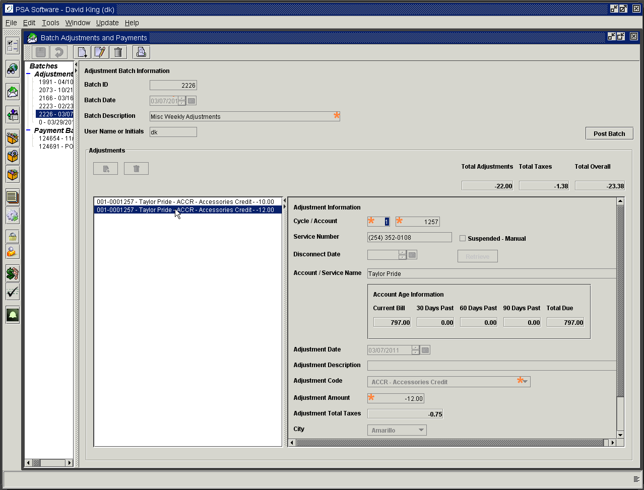

Press Save to close entry of adjustment or New icon in the sub frame to continue with next adjustment. Notice the three fields above the sub frame named Total Adjustments, Total Taxes, and Total Overall. As you add adjustments, these fields will be updated. Keep in mind not all adjustments will have taxes associated with the amount. That is determined when the adjustment item is created. Total Overall is the net total amount of adjustments both positive and negative and associated taxes for the batch.

Trial Balance Adjustment Report

The user may print a batch trial at any time by using the Print icon in the menu bar.

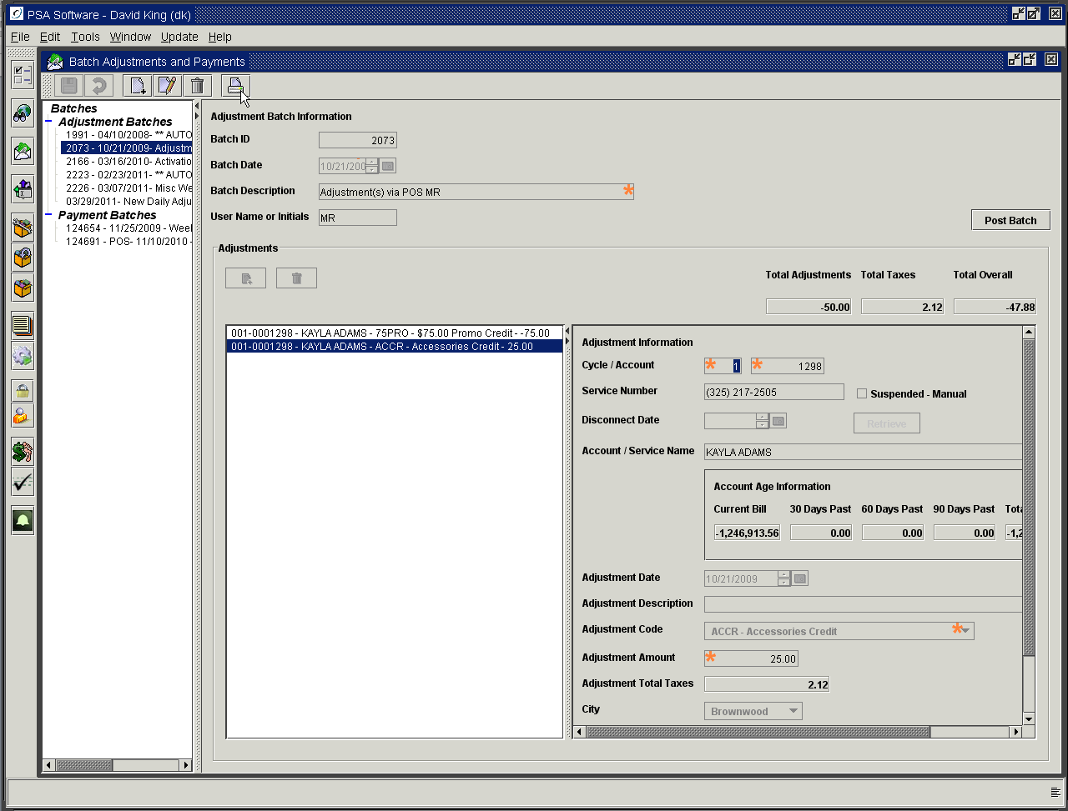

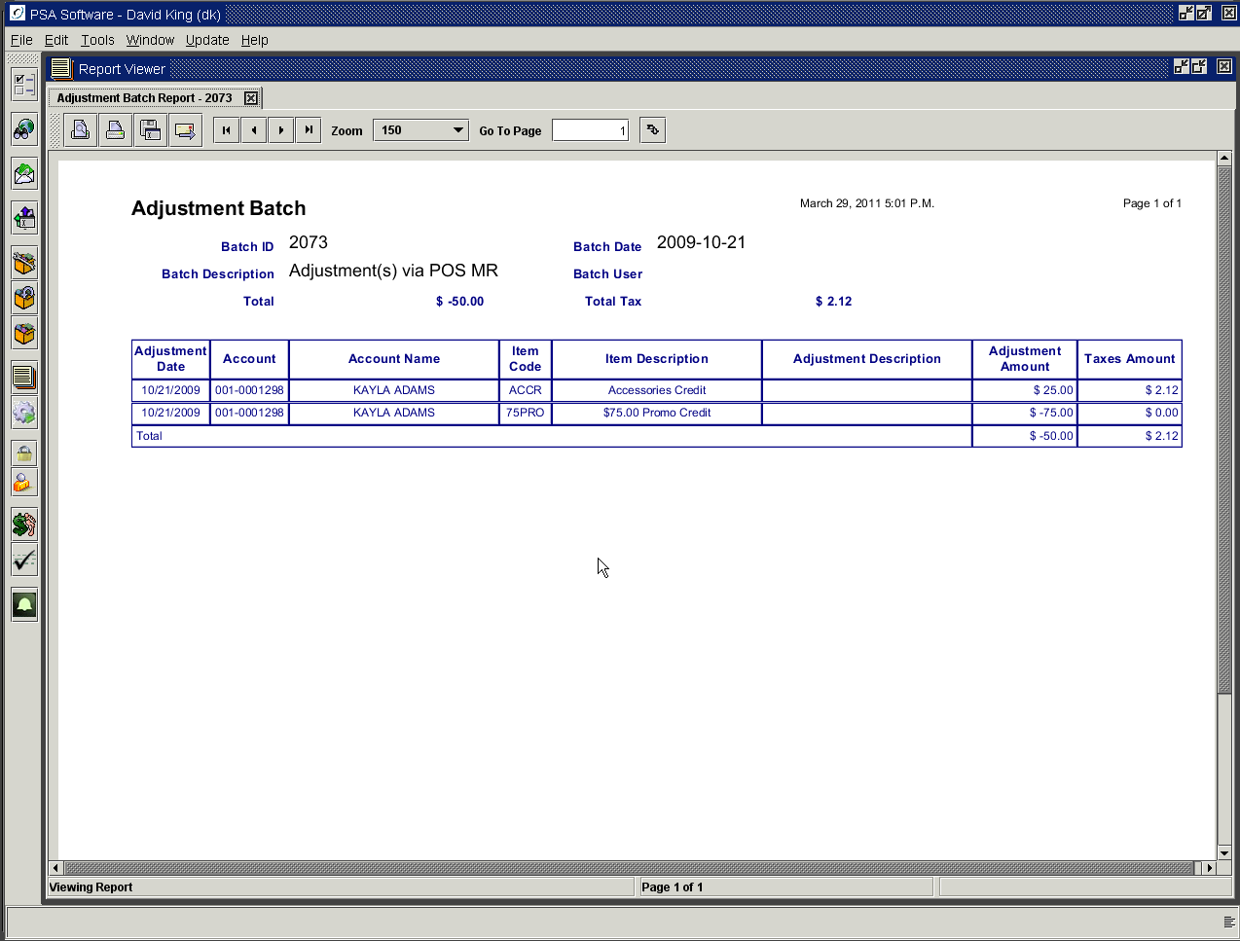

Deleting Un-Posted Adjustments

Delete icon: Use the delete icon to remove an incorrect adjustment. Highlight the adjustment in the list and press the Trash Can icon in the subframe. You will be asked to confirm the deletion.

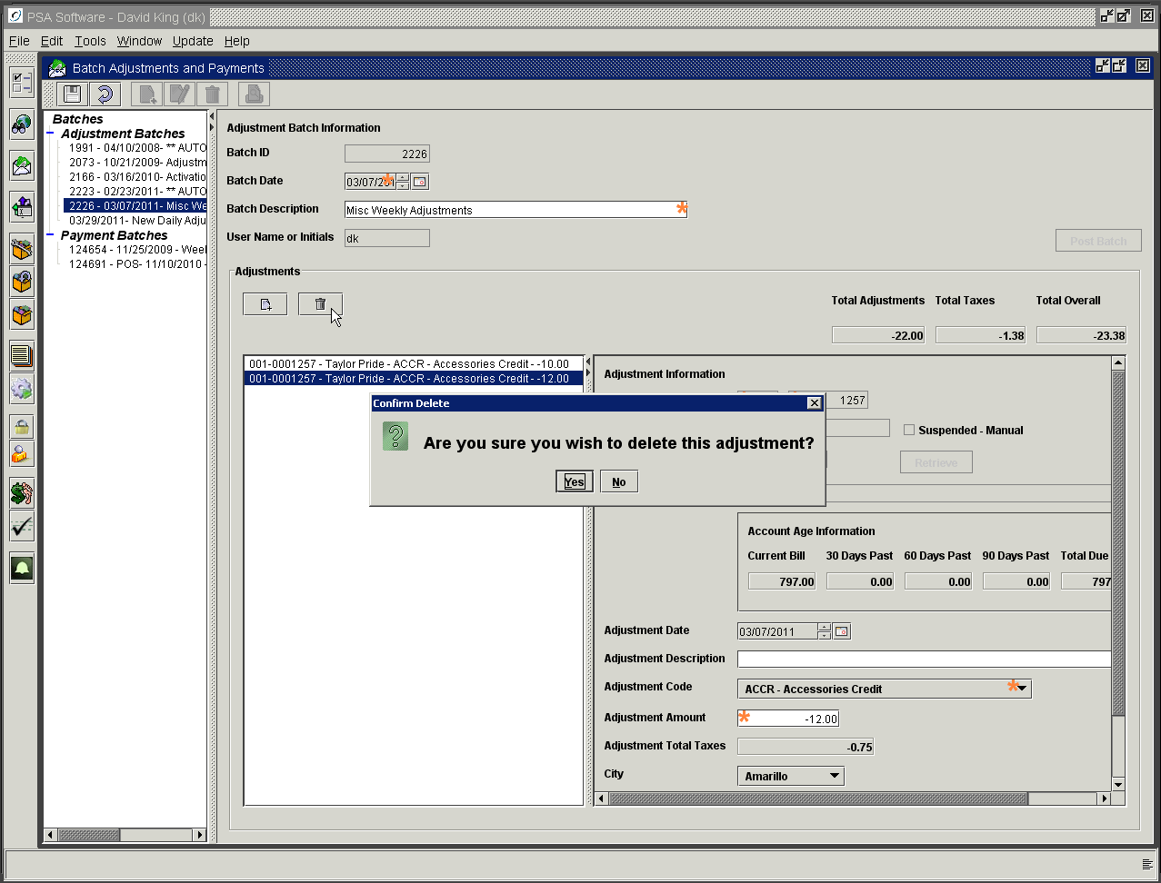

Post Adjustment Batch/Print Final Batch Report

Once all adjustments are entered for the batch and saved, the user will need to Post the batch. Posting applies the adjustments to the customer’s accounts receivable at the time of posting.

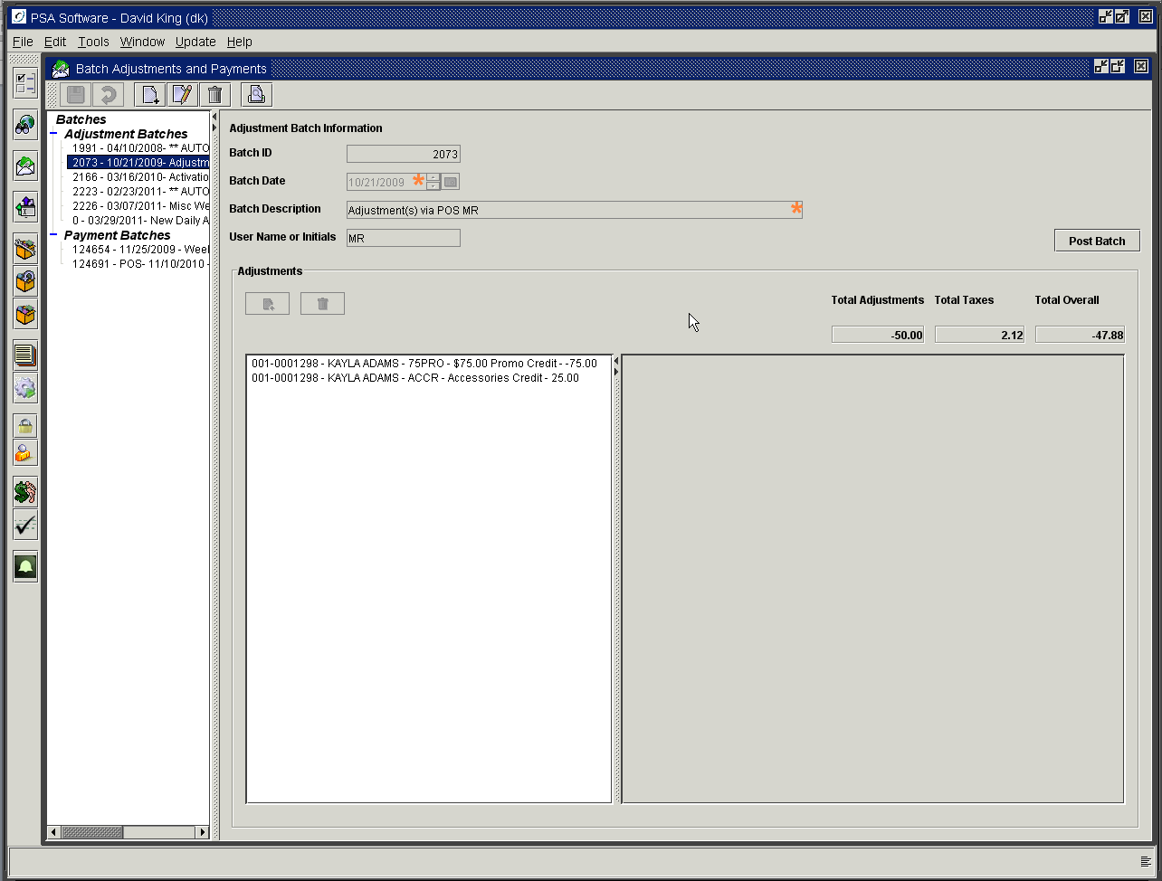

Select the batch from the tree to the right and press Post Batch.

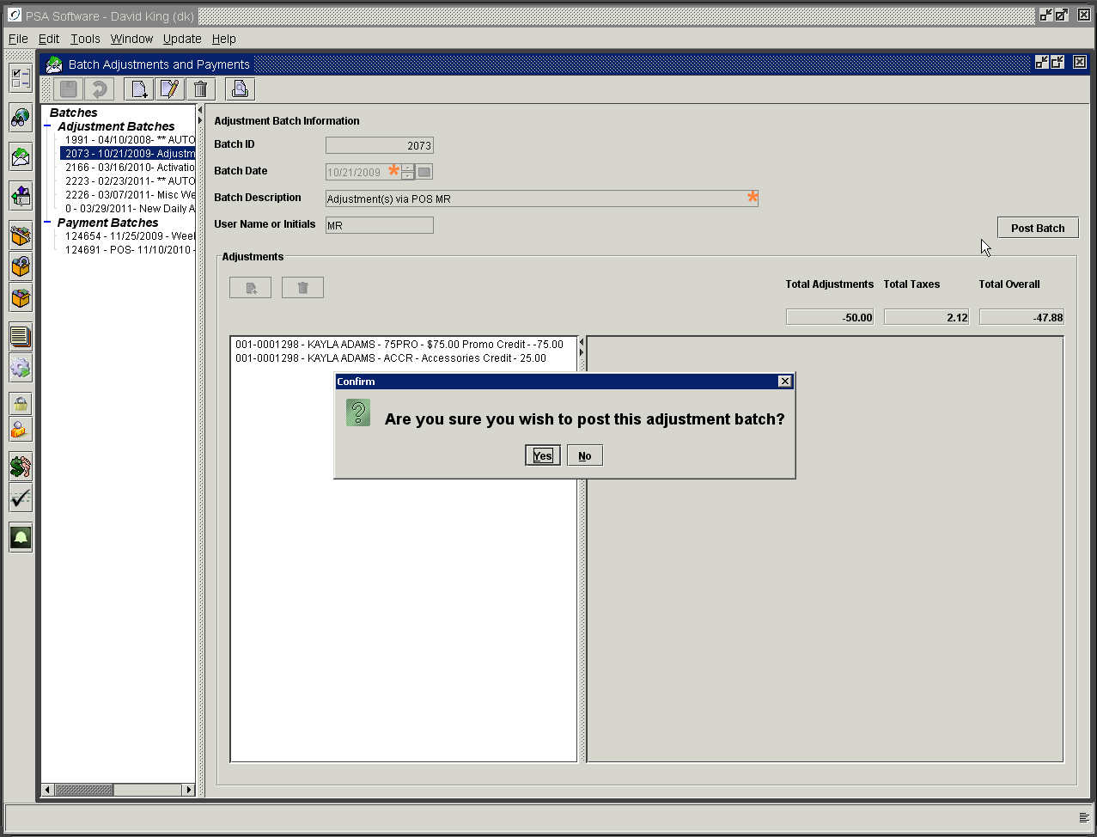

Yes will post the batch and create a Final Batch report. No will cancel the post.

NOTE: Adjustments will not appear anywhere on the customer’s records, reports or summary screen until they have been posted.

Removing Posted Adjustments

Posted Adjustments must be removed by PSA support - check batches thoroughly before posting. You cannot simply undo an adjustment.

Batch Payments

Create New Batch
New Batch
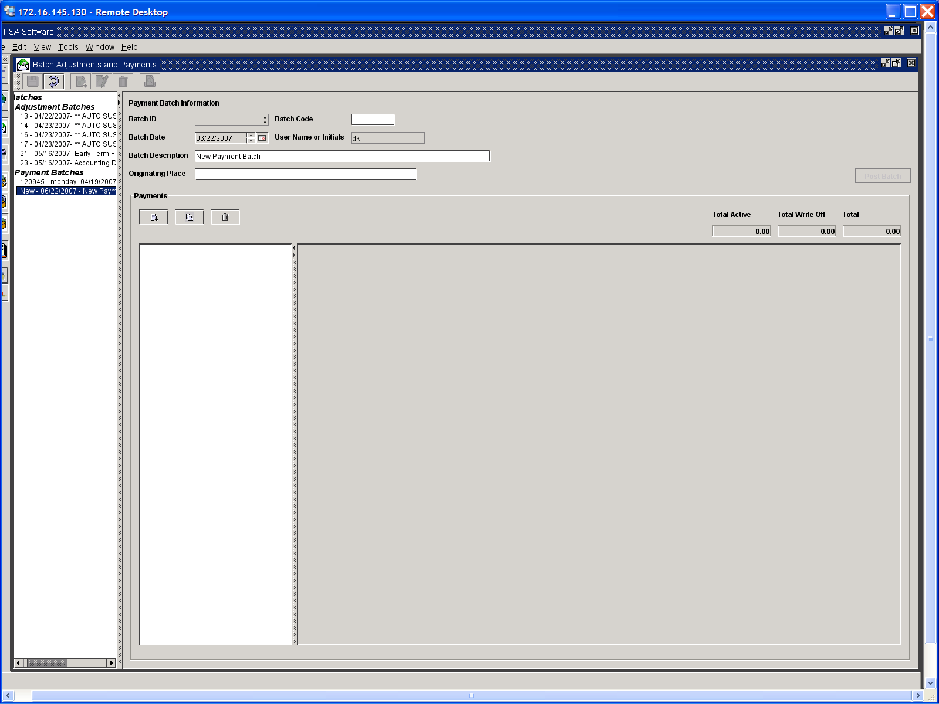
Scan Barcode
New Payment

Batch ID: Is a unique system generated number. This will used for retrieval or posting.
Batch Code: This is a user-generated code to help differentiate between batches. (optional)
Batch Date: This is the date the batch was created. This is not the date that will be shown on the statement. The date shown as payment date on the statement is the date entered in the sub frame area.
Batch Description: Text description of batch.
Originating Place: Can be used if you would like to track where payments are accepted. (Optional)

Payment Sub Frame

New icon: Opens a blank payment sub-screen. This will create a payment template for manual entry of payments. Partial payments, where the payment is NOT the full amount owed on the account, will need to be manually entered. You begin by locating the customer account. You can enter the account number or service number in the appropriate field. If using the service number to locate the account, remember if the service number has been disconnected, the disconnect date must also be entered. When you press Retrieve, the program will search to locate an account for the entered data. With a valid number, an account will be loaded; otherwise a message for no account found will be delivered. The account load will display the account name and the total amount due in the payment amount field. If your statements have a barcode on the remittance slip, you can use the scanner to enter the account number by placing the cursor in the account field. Scan the bar code. The scan will locate the customer account as if you had typed the number in the field. If it is a partial payment, you will need to change the payment amount and press either new or save to continue. Pressing New creates a new template; Save updates the batch and stops entry.

Scanning Payments

Scan icon: Pressing the middle Scan button allow the user to scan the barcode on the remittance slip to retrieve the customer information and payment amount. NOTE: Scanning should be used only for full payments. (ie. Payments that will pay the account off in full). Each time you press the trigger on the scanner, the information will be retrieved and entered into the batch without any further intervention. The payments will be moved to a queue and will begin showing in the Payment sub frame tree as they are processed. According to the speed of the scanner, your processor, the CSR etc., it may a few minutes for all the payments to show in the tree.

Also you will not have a chance to change any fields or add to the Payment Reference field when scanning payments. It is recommended that the CSR separate payments into two groups for processing. One group that has made full payments on the account, and another group that have made partial payments. Process one group and check the payment total for that group. Then process the second group and check the Total for the combined total of the two batches at the end of both groups.

To stop scanning, press the ‘New Payment’ icon or the Save icon. Once the batch is complete, press Save to update the batch. Saving the batch does NOT post the payment.

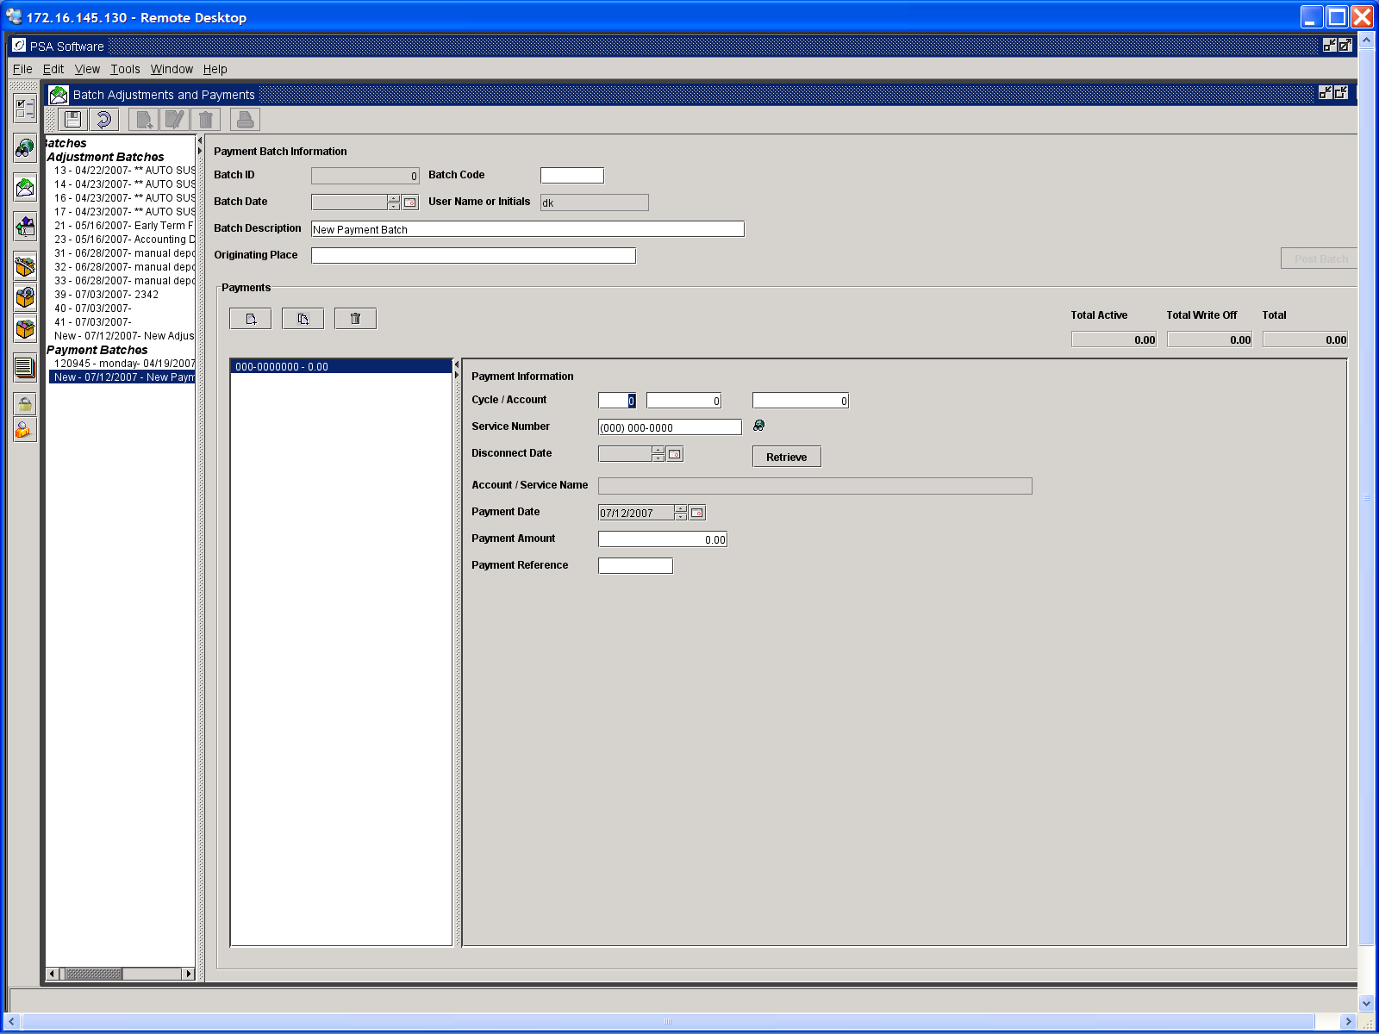
Bill Date Field
Payment Date Field

Manual Entry of Payments
For manual entry of partial payments or if you do not use a scanner, enter either the account number or service number (the user does not have to enter both). If you enter the account number, enter the cycle and account number. If you press Retrieve at this point, the customer name will be returned and the payment amount field will be 0.00. If you enter a bill date after the account number and then press Retrieve, the customer name will be entered and the current balance on the account will be entered in the payment amount field. Remember if you use the service number and the account is disconnected you will need to enter the disconnect date.

Cycle/Account Number:
Bill Date: If you want to retrieve a balance on the account in manual entry, you must enter the bill date here. The format would be CCYYMMDD. Where the billing date is the first of the month, the February billing date for 2009 should be entered 20090201.

Service Number:
Search: If you need to look up an account number or service number, press the Search icon next to service number. You must press the Search button once you are in the search panel. Due to java restrictions, pressing Enter on the keyboard will not start the search.
Disconnect Date: Must be used in conjunction with the service number if the service number is not active to pull up the account.
Retrieve Button: Pressing this button retrieves the customer data for verification of account.
Account/Service Name: Name on the account.
Payment Date: This is the date that will be shown in payment history and on the statement.
Payment Amount: This amount will be defaulted from the balance due on the account by the service program. If the actual amount is different from the default amount (such as a partial payment), change the amount and go to the next field.
Payment Reference: This is an alphanumeric field; many clients use this field to record check numbers.

Total Active: These are payments for currently active accounts.
Total Write-Off: These are payments that will be directed to accounts that have been written off.
Total: This is the total of both the active payments and payments that were directed to write off accounts.

Trial Balance Payment Report

A trial balance report for a batch of payments may be created while the batch is still open by pressing the Print icon in the tool bar. To print other trial balance reports select and open the batch and press the Print icon. See the Retrieving Payment Reports section below for additional options.

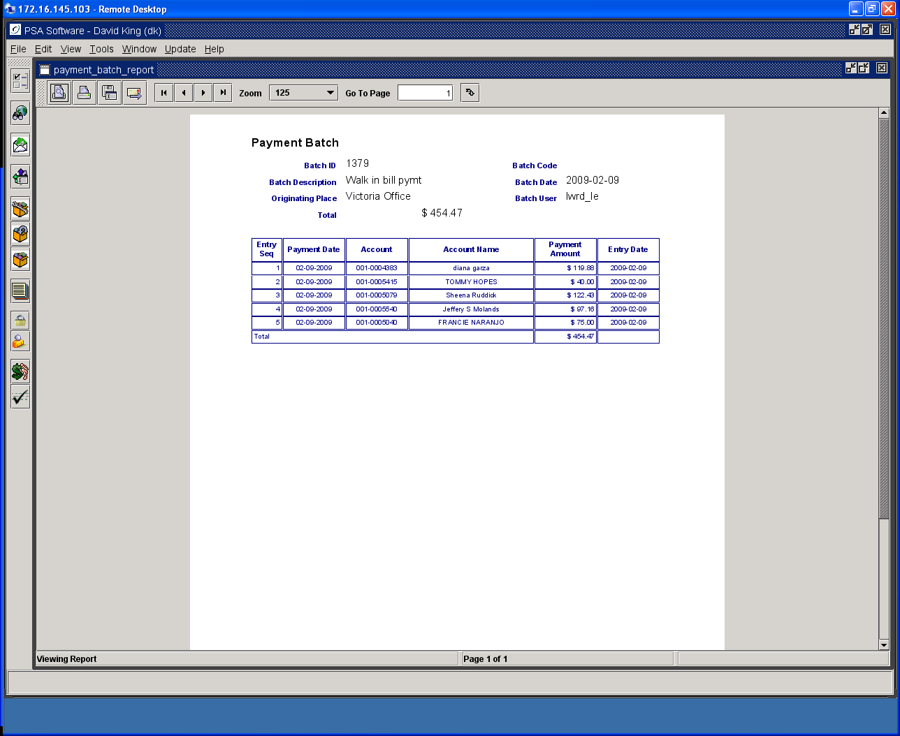

Deleting Un-Posted Payments
While the batch is still open you may remove an incorrectly entered payment; however after posting a payment can only be removed by designated persons within the company or by PSA personnel. Please double check the batch and totals prior to posting a batch.

Trash Can icon: Use the delete icon to remove an incorrect payment. Highlight the payment in the list and press the Delete icon.

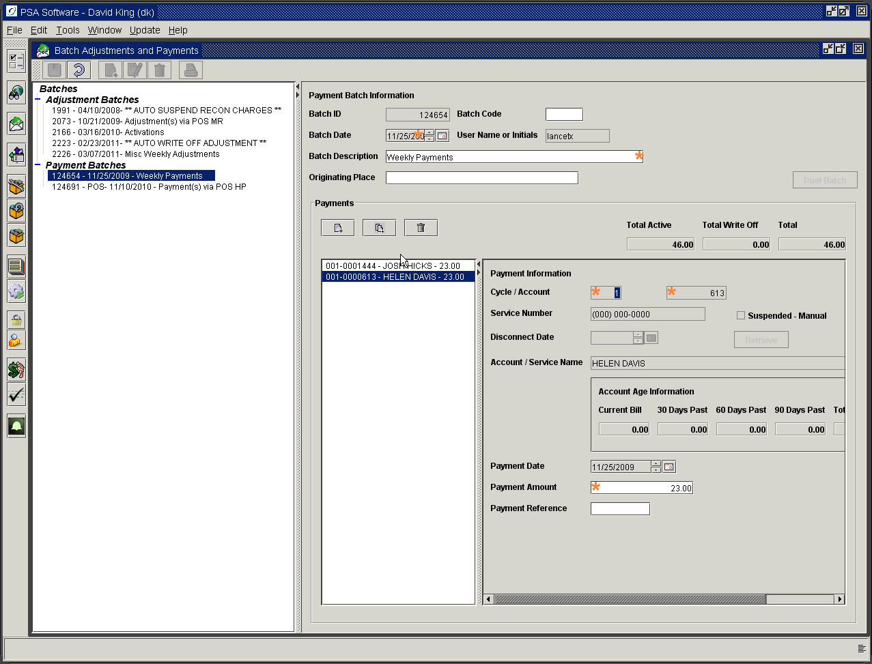
Delete
Payment

Pressing Save closes the current payment batch.

Posting of Payments

Once all payments are entered for the batch and saved, the user will need to Post the batch. Posting applies the payments to the customer’s accounts receivable at the time of posting. Select the batch from the tree to the right and press Post Batch button.

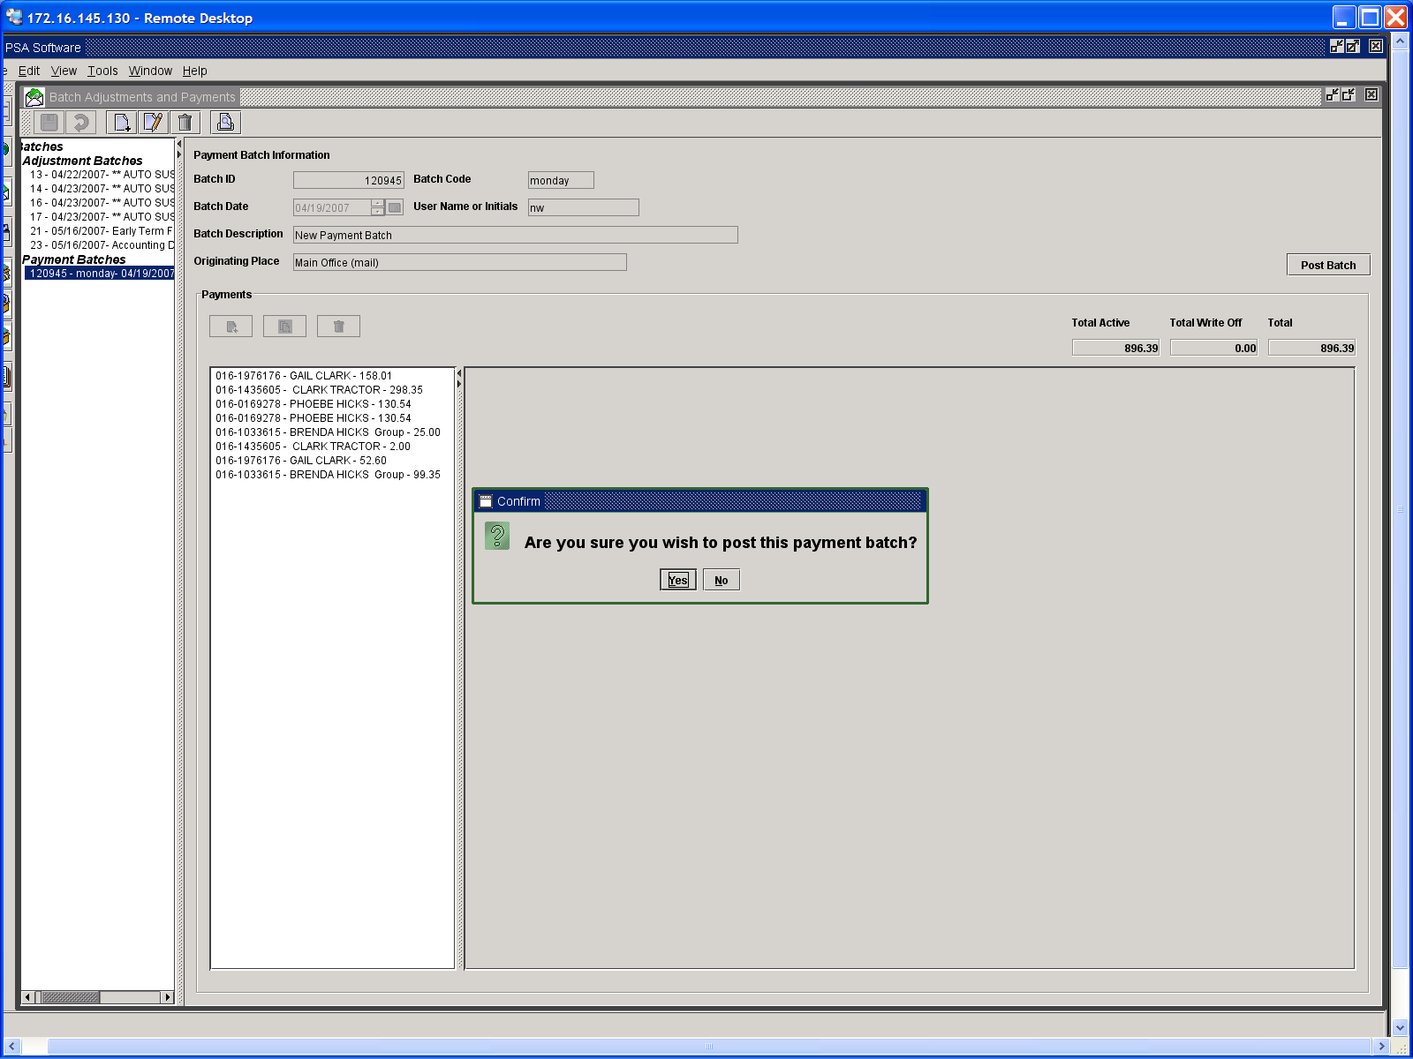

Yes will post the batch and create a Final Batch report. No will cancel the post. The status will show Posted.
You may email or print the displayed report. Once the batch is posted it will no longer be shown in the tree on the left.

When the post is final you will see the status is shown as Posted. To print the final batch report press the Print icon.

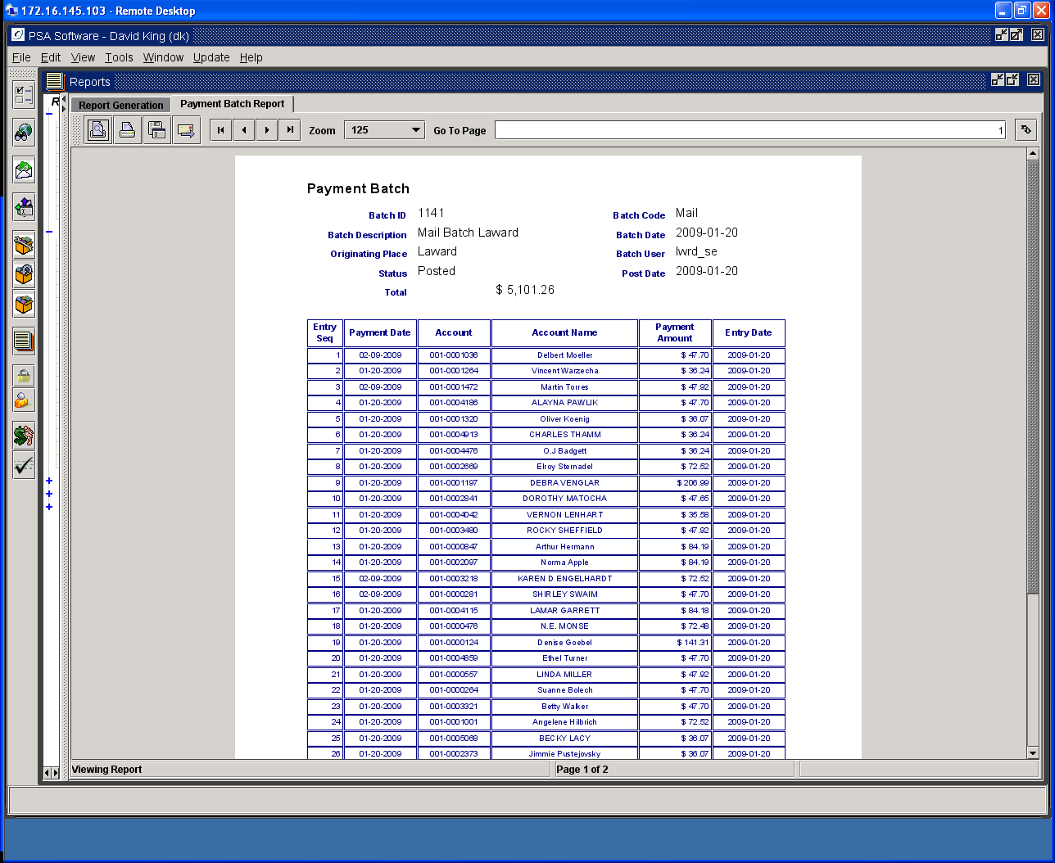

NOTE: Payments will not appear anywhere on the customer’s records, reports or summary screen until they have been posted.

Removing Posted Payments

Posted Payments must be removed by PSA support - check batches thoroughly before posting. You cannot just simply undo a payment.

Retrieving Payment Reports – Payment Batch Report
Here is an alternate way to print a trial balance for review. Click on the Reports icon and select Batch Adjustments and Payments. Select Payment Batch Report. Begin by entering the batch number under review and press View Report. If the batch has been posted then the status will show as Posted, if not there will be no status shown.
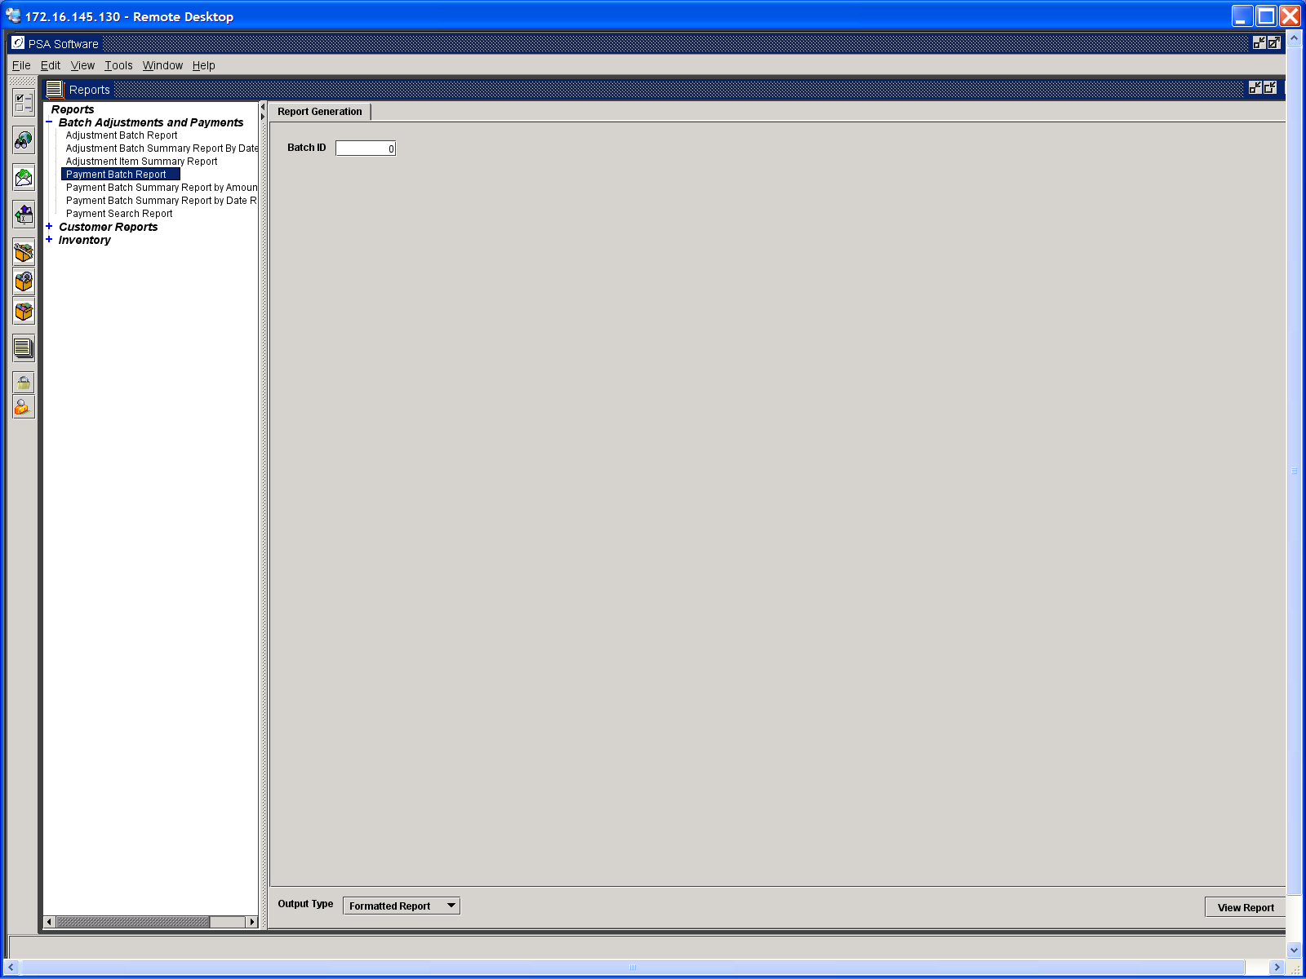

You may now print the report, email the report or export the report to a file for review.

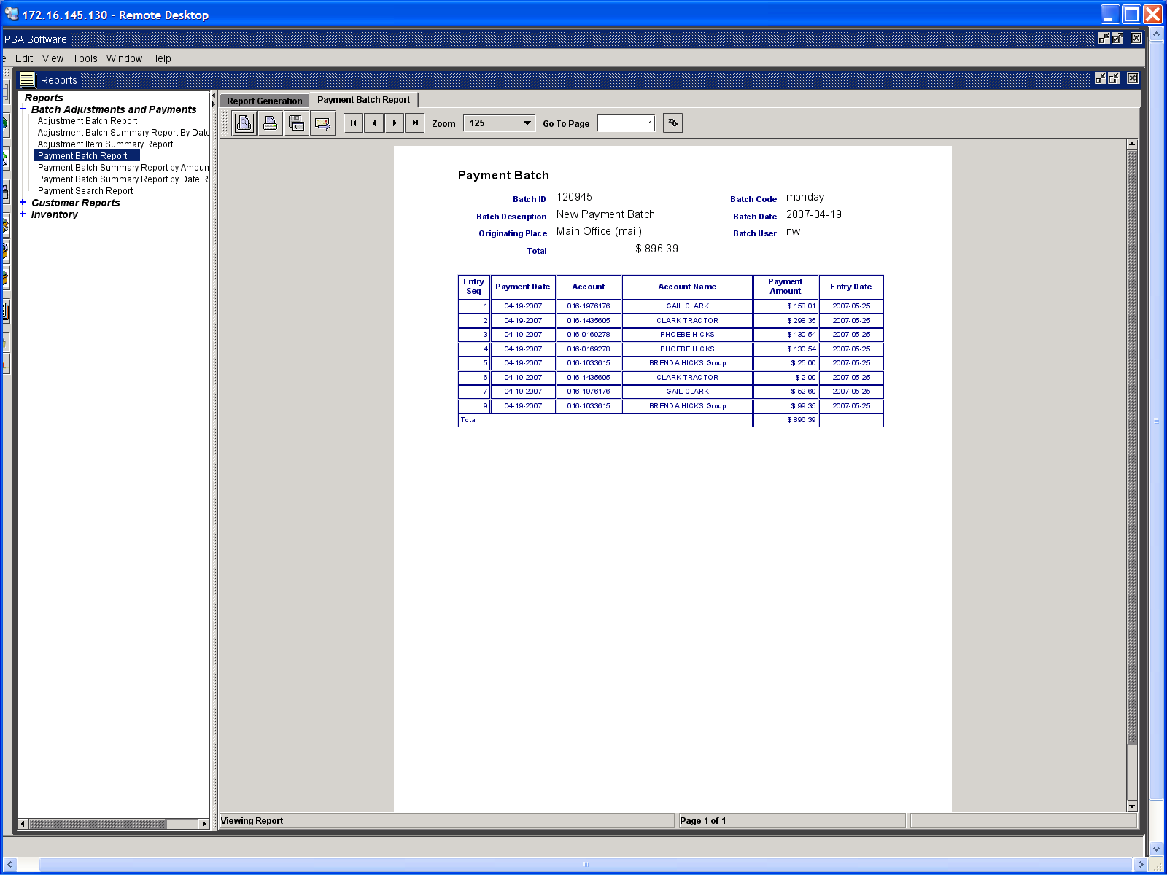

Finding Payments

Payment Search Report

You may locate payments within a date range by dollar amount. For instance, a payment for 122.43 does not appear on the customer’s payment reports and has potentially been credited to the wrong account. You know the payment was processed between 01/09/2009 and 02/09/2009. To see all payments that match your criteria, enter the data on the Payment Search Report under Desktop Reports, Batch Adjustments and Payments. The report will return all instances that match the data.

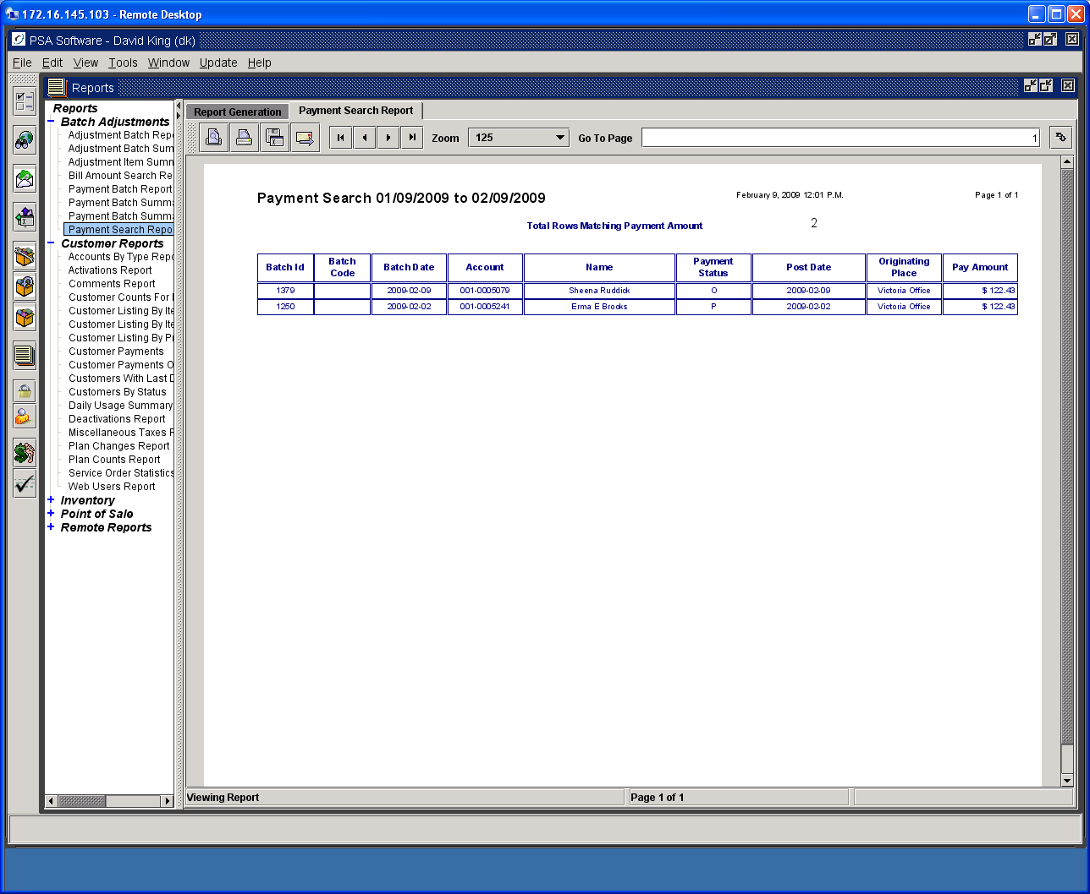

Locating Batches or Checking for Non- Posted Batches

Payment Batch Summary by Amount
Payment Batch Summary by Date Range

These two reports return the same information. The first report works well if you know the batch total. It will only locate batches with that specific total of payments, thus returning fewer batches for review. The second report returns all the batches created within the date range you provide. Keep in mind that the dates being searched are the batch creation date, not the payment date. This report will show all batches posted or un-posted batches that were created between the dates provided. It would always be a good idea to check here prior to any bill run to make sure all payments have been posted. Batch status of P means the payments are posted. The status of O means the batch is still open and needs to be posted at some point.

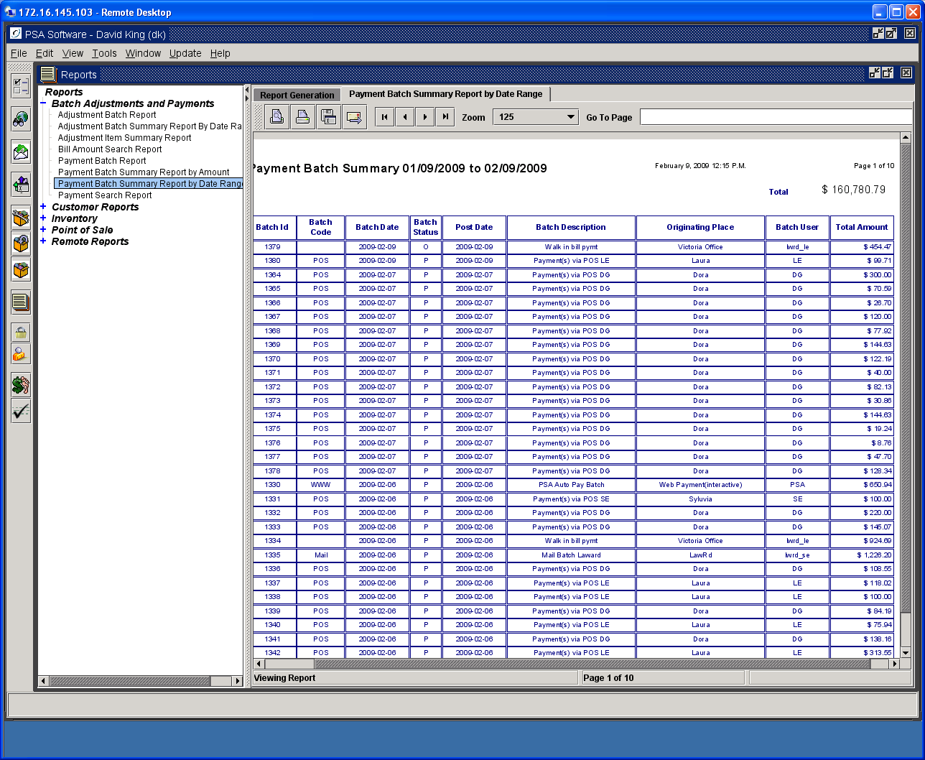

Possible Payment Duplicates Report
You may check to see if a payment was entered multiple times during a period. Select the date range and press View Report. This will display all payments that are equal on an account on the same day. If they are on different dates they will not show on this report. If a customer should submit a payment via the web several times then you would be able to catch that on this report. If two CSR’s entered the same payment on the same day, that payment would be shown on this report.

